**1. Class diagram**

I. class object

MFC

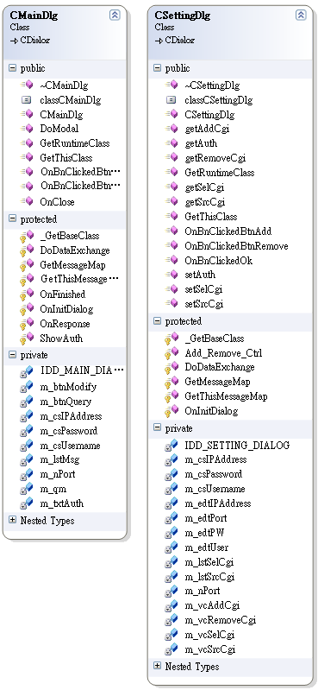

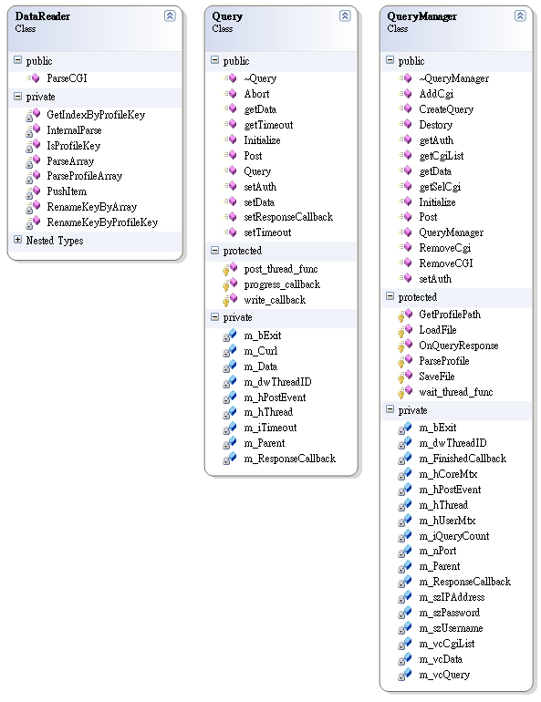

II. internal API

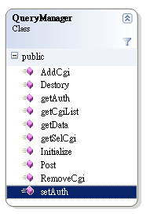

**2. Activity Diagram**

I. Initial Activity

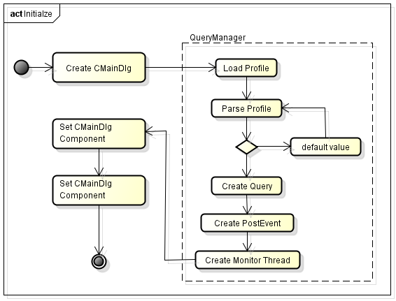

II. UI Activity

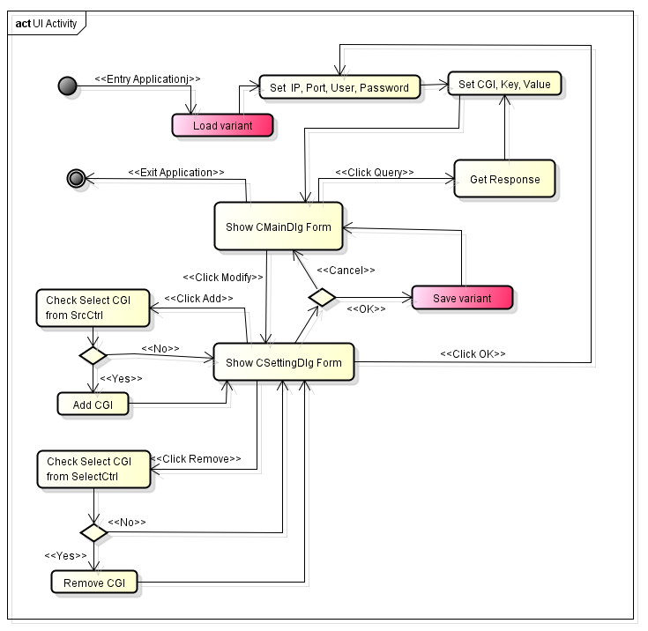

III. Data Activity

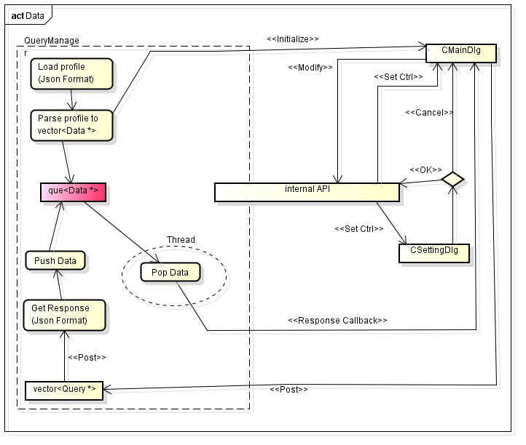

**3.資料結構**

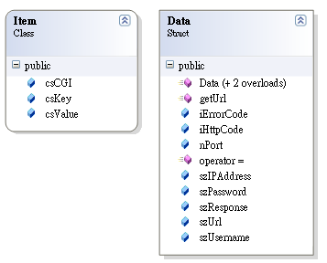

**4. 檔案格式**

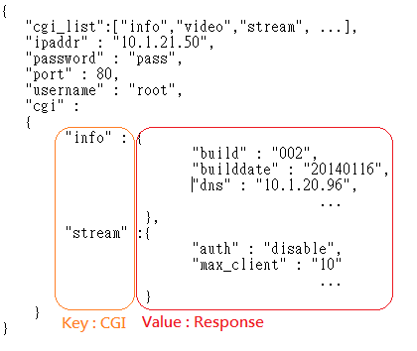

cgi_list : CGI來源清單

cgi : 所選擇的cgi 清單

**5.程式碼細部規劃**

void Initialize(

void(*finished_callback)(void *, QueryManager *),

void(*response_callback)(void *, Data *));

void Destory();

void getAuth(string &chUser, string &chPW, string &chIP, short &nPort);

void setAuth(string chUser, string chPW, string chIP, short nPort);

void Post();

bool getCgiList(vector<string> &cgi_list);

void getSelCgi(vector<string> &cgi_list);

void AddCgi(string szCgi);

void RemoveCgi(string szCgi);

